MẠNG MÁY TÍNH
Quarter 1, year 2024-2025
Section 1 (60 marks)
Question 1: What is the purpose of Subnet mask in IP subnetting?
A. Assign unique identifiers to devices
B. Identify the network portion of an IP address
C. Encrypt network traffic
D. Manage dynamic IP addresses
Question 2: Which of the following address belongs to class B?
A. 10.10.114.24
B. 127.12.12.248
C. 128.12.12.248
D. 192.168.12.248
Question 3: Which protocol is used for receiving emails over the internet?
A. SMTP
B. FTP
С. НТТР
D. POP3
Question 4: What is the prefix length notation for the subnet mask 255.255.255.252?
A. /28
B. /32
C. /30
D. /24
Question 5: Assume that we have the network 200.200.20.0/24 and we want to divide it into a subnet with 100 PCs. What is the last IP address?
A. 200.200.20.126
B. 200.200.20.127
C. 200.200.20.128
D. 200.200.20.100
Question 6: What is the subnet mask of the network 172.16.0.0/10?
А. 255.254.0.0
B. 255.255.0.0
C. 255.252.0.0
D. 255.192.0.0
Question 7: Given the binary version of an IP as follow: 11000000.10101000.00001010.00000001
What is the decimal version of this IP?
A. 192.168.10.1
В. 192.224.10.1|
C. 192.168.10.2
D. 192.224.1.0
Question 8: What is the default subnet mask for Class C IP address?
A. 255.255.0.0
B. 255.255.255.0
C. 255.0.0.0
D. 255.255.255.255
Question 9: Which command generate the output shown in the figure below?
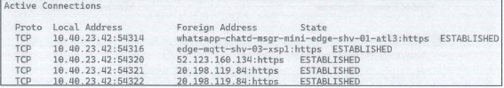
A. ping
B. route
C. netstat
D. nslookup
Question 10: Given the decimal version of an IP as follow: 172.16.0.254. What is the binary version of
А. 10101100.00010000.00000000.11111110
В. 10101100.10101000.00001010. 11111111|
C. 10101100.00010000.00000000.11111111|
D. 10101100.00100000.00000000.11111110|
Question 11: Assume that we have the network 192.168.10.0/24 and we want to divide it into subnets, each subnet contains 50 PCs. What is the first IP address of the 2nd subnet?
A. 192.168.10.51
B. 192.168.10.65
C. 192.168.10.50
D. 192.168.10.64
Question 12: The message is sent form Source PC to all other PCs as shown below. What type of data communication is this?
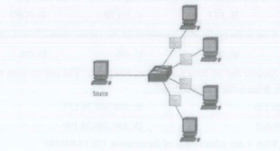
A. Broadcast
C. Unicast
B. Multicast
D. All off the above
Question 13: What is the port number of DNS protocol?
A. 20
B. 53
C. 22
D. 21.
Question 14: What is the possible reason for the problem shown in the picture below?
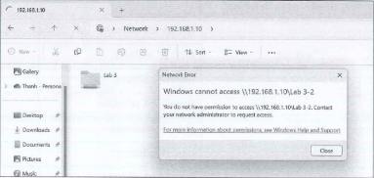
A. Wrong user name or password
B. The shared folder has been deleted
C. Wrong IP address of the Hostq
D. No access permission for this user
Question 15: What is the correct order of OSI layers?
A. Physical → Data-link → Network → Transport - Session -Presentation - Application
B. Physical → Data-link → Transport → Network → Session - Presentation - Application
C. Network → Physical - Data-link → Transport → Session → Application → Presentation
D. Physical → Data-link - Network → Transport - Presentation → Session → Application
Question 16: What does the term MAN in Computer network stand for?
A. Micro Area Network
B. Multi-access Network
C. Metropolitan Area Network
D. Macro Area Network|
Question 17: What is the private IP range for Class C?
A. 10.0.0.0 to 10.255.255.255
B. 172.16.0.0 to 172.31.255.255|
С. 192.168.0.0 to 192.168.255.255
D. 192.0.0.0 to 223.255.255.0
Question 18: Which one of the following is a network topology?
A. Sphere
B. Peer to Peer
C. Car
D. Ring
Question 19: Which IP address class allocates 16 bits for the host identification part?
A. Class A
B. Class B
C. Class C
D. Class D
Question 20: Why do we need IP subnetting?
A. To divide a large network into smaller, more manageable segments
B. To connect two geographically distant networks together
C. To establish a secure connection between a client and a server
D. To translate private IP addresses into public IP addresses
